**1. Git-HOL**

user@DESKTOP-TB29U4O MINGW64 ~

$ git version

git version 2.50.1.windows.1

user@DESKTOP-TB29U4O MINGW64 ~

$ git config --global user.name "ssha22039.cb"

user@DESKTOP-TB29U4O MINGW64 ~

$ git config --global user.email "ssha22039.cb@rmkec.ac.in"

user@DESKTOP-TB29U4O MINGW64 ~

$ git config --global --list

user.name=ssha22039.cb

user.email=ssha22039.cb@rmkec.ac.in

user@DESKTOP-TB29U4O MINGW64 ~

$ git init GitDemo

Initialized empty Git repository in C:/Users/user/GitDemo/.git/

user@DESKTOP-TB29U4O MINGW64 ~

$ cd GitDemo

user@DESKTOP-TB29U4O MINGW64 ~/GitDemo (master)

$ ls -al

total 12

drwxr-xr-x 1 user 197121 0 Aug 10 17:57 ./

drwxr-xr-x 1 user 197121 0 Aug 10 17:58 ../

drwxr-xr-x 1 user 197121 0 Aug 10 17:57 .git/

user@DESKTOP-TB29U4O MINGW64 ~/GitDemo (master)

$ echo "Welcome to version control">>welcome.txt

user@DESKTOP-TB29U4O MINGW64 ~/GitDemo (master)

$ cat welcome.txt

Welcome to version control

user@DESKTOP-TB29U4O MINGW64 ~/GitDemo (master)

$ git status

On branch master

No commits yet

Untracked files:

(use "git add <file>..." to include in what will be committed)

welcome.txt

nothing added to commit but untracked files present (use "git add" to track)

user@DESKTOP-TB29U4O MINGW64 ~/GitDemo (master)

$ git add welcome.txt

warning: in the working copy of 'welcome.txt', LF will be replaced by CRLF the next time Git touches it

user@DESKTOP-TB29U4O MINGW64 ~/GitDemo (master)

$ git commit

hint: Waiting for your editor to close the file... unix2dos: converting file C:/Users/user/GitDemo/.git/COMMIT_EDITMSG to DOS format...

dos2unix: converting file C:/Users/user/GitDemo/.git/COMMIT_EDITMSG to Unix format...

[master (root-commit) 4c0e3a8] add welcome.txt

1 file changed, 1 insertion(+)

create mode 100644 welcome.txt

user@DESKTOP-TB29U4O MINGW64 ~/GitDemo (master)

$ git status

On branch master

nothing to commit, working tree clean

user@DESKTOP-TB29U4O MINGW64 ~/GitDemo (master)

$ git pull origin master

fatal: 'origin' does not appear to be a git repository

fatal: Could not read from remote repository.

Please make sure you have the correct access rights

and the repository exists.

user@DESKTOP-TB29U4O MINGW64 ~/GitDemo (master)

$ git push origin master

fatal: 'origin' does not appear to be a git repository

fatal: Could not read from remote repository.

Please make sure you have the correct access rights

and the repository exists.

user@DESKTOP-TB29U4O MINGW64 ~/GitDemo (master)

$ git remote add origin https://gitlab.com/cognizant-dn4.0/GitDemo

user@DESKTOP-TB29U4O MINGW64 ~/GitDemo (master)

$ git push origin master

info: please complete authentication in your browser...

warning: redirecting to https://gitlab.com/cognizant-dn4.0/GitDemo.git/

Enumerating objects: 3, done.

Counting objects: 100% (3/3), done.

Writing objects: 100% (3/3), 243 bytes | 121.00 KiB/s, done.

Total 3 (delta 0), reused 0 (delta 0), pack-reused 0 (from 0)

remote:

remote: To create a merge request for master, visit:

remote: https://gitlab.com/cognizant-dn4.0/GitDemo/-/merge_requests/new?merge_request%5Bsource_branch%5D=master

remote:

To https://gitlab.com/cognizant-dn4.0/GitDemo

* [new branch] master -> master

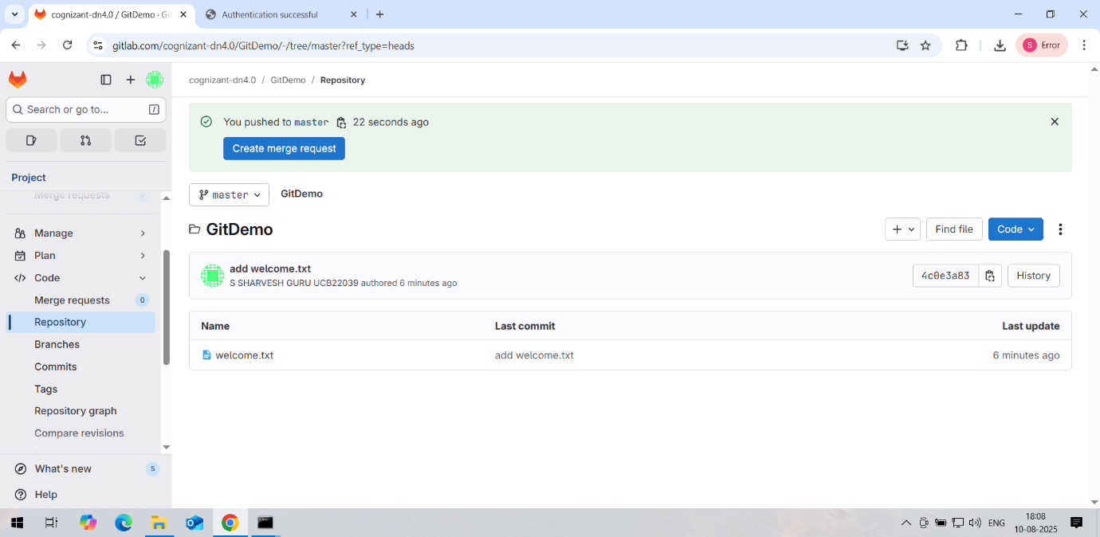

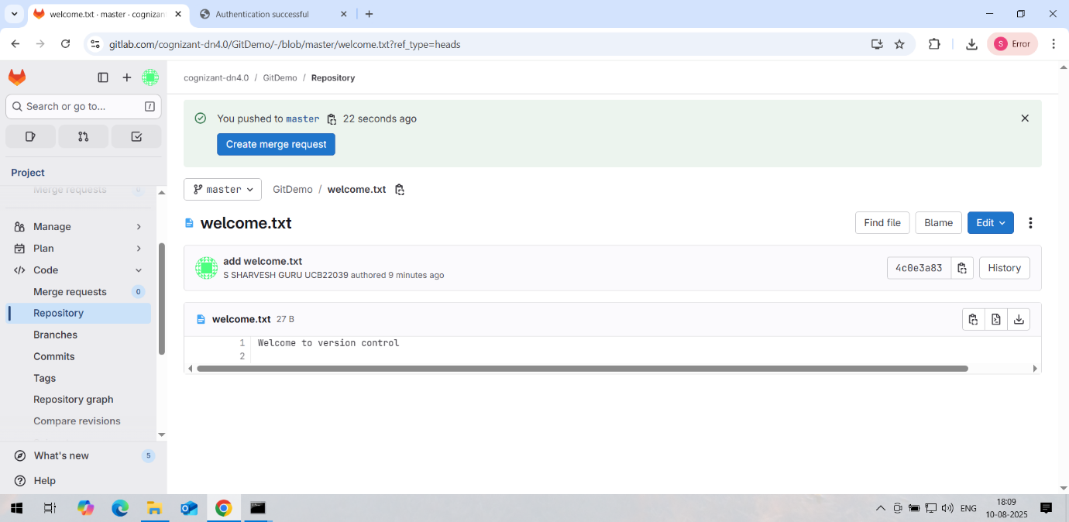

**2. Git-HOL**

user@DESKTOP-TB29U4O MINGW64 ~

$ cd GitDemo

user@DESKTOP-TB29U4O MINGW64 ~/GitDemo (master)

$ ls

welcome.txt

user@DESKTOP-TB29U4O MINGW64 ~/GitDemo (master)

$ mkdir log

user@DESKTOP-TB29U4O MINGW64 ~/GitDemo (master)

$ cd log

user@DESKTOP-TB29U4O MINGW64 ~/GitDemo/log (master)

$ echo "Sample log">>example.log

user@DESKTOP-TB29U4O MINGW64 ~/GitDemo/log (master)

$ cd ..

user@DESKTOP-TB29U4O MINGW64 ~/GitDemo (master)

$ touch .gitignore

user@DESKTOP-TB29U4O MINGW64 ~/GitDemo (master)

$ nano .gitignore

user@DESKTOP-TB29U4O MINGW64 ~/GitDemo (master)

$ cat .gitignore

/log

*.log

user@DESKTOP-TB29U4O MINGW64 ~/GitDemo (master)

$ git add .

warning: in the working copy of '.gitignore', LF will be replaced by CRLF the next time Git touches it

user@DESKTOP-TB29U4O MINGW64 ~/GitDemo (master)

$ git commit -m "Add gitignore"

[master 50222fc] Add gitignore

1 file changed, 2 insertions(+)

create mode 100644 .gitignore

user@DESKTOP-TB29U4O MINGW64 ~/GitDemo (master)

$ git push origin master

warning: redirecting to https://gitlab.com/cognizant-dn4.0/GitDemo.git/

Enumerating objects: 4, done.

Counting objects: 100% (4/4), done.

Delta compression using up to 3 threads

Compressing objects: 100% (2/2), done.

Writing objects: 100% (3/3), 285 bytes | 95.00 KiB/s, done.

Total 3 (delta 0), reused 0 (delta 0), pack-reused 0 (from 0)

remote:

remote: To create a merge request for master, visit:

remote: https://gitlab.com/cognizant-dn4.0/GitDemo/-/merge_requests/new?merge_request%5Bsource_branch%5D=master

remote:

To https://gitlab.com/cognizant-dn4.0/GitDemo

4c0e3a8..50222fc master -> master

user@DESKTOP-TB29U4O MINGW64 ~/GitDemo (master)

$ ls -al

total 14

drwxr-xr-x 1 user 197121 0 Aug 10 18:13 ./

drwxr-xr-x 1 user 197121 0 Aug 10 18:04 ../

drwxr-xr-x 1 user 197121 0 Aug 10 18:14 .git/

-rw-r--r-- 1 user 197121 11 Aug 10 18:14 .gitignore

drwxr-xr-x 1 user 197121 0 Aug 10 18:12 log/

-rw-r--r-- 1 user 197121 27 Aug 10 17:59 welcome.txt

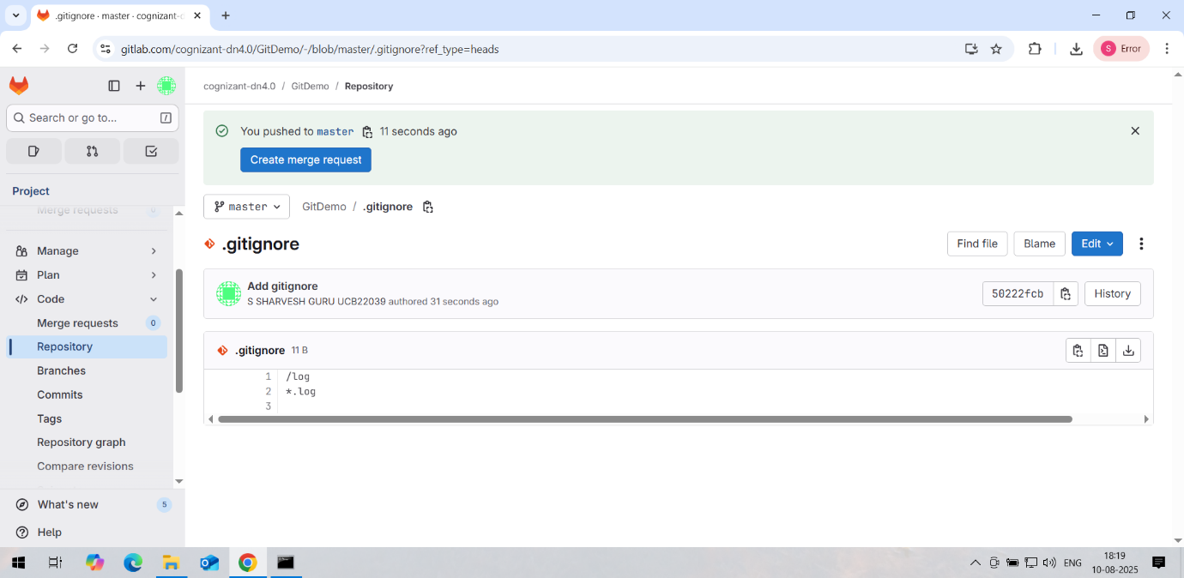

**3. Git-HOL**

user@DESKTOP-TB29U4O MINGW64 ~/GitDemo (master)

$ git branch GitNewBranch

user@DESKTOP-TB29U4O MINGW64 ~/GitDemo (master)

$ git branch

GitNewBranch

* master

user@DESKTOP-TB29U4O MINGW64 ~/GitDemo (master)

$ git branch -r

origin/master

user@DESKTOP-TB29U4O MINGW64 ~/GitDemo (master)

$ git checkout GitNewBranch

Switched to branch 'GitNewBranch'

user@DESKTOP-TB29U4O MINGW64 ~/GitDemo (GitNewBranch)

$ echo "Sample content for new branch" > newfile.txt

user@DESKTOP-TB29U4O MINGW64 ~/GitDemo (GitNewBranch)

$ git add newfile.txt

warning: in the working copy of 'newfile.txt', LF will be replaced by CRLF the next time Git touches it

user@DESKTOP-TB29U4O MINGW64 ~/GitDemo (GitNewBranch)

$ git commit -m "Added newfile.txt with initial content"

[GitNewBranch a038196] Added newfile.txt with initial content

1 file changed, 1 insertion(+)

create mode 100644 newfile.txt

user@DESKTOP-TB29U4O MINGW64 ~/GitDemo (GitNewBranch)

$ git status

On branch GitNewBranch

nothing to commit, working tree clean

user@DESKTOP-TB29U4O MINGW64 ~/GitDemo (GitNewBranch)

$ git checkout master

Switched to branch 'master'

user@DESKTOP-TB29U4O MINGW64 ~/GitDemo (master)

$ git diff master..GitNewBranch

diff --git a/newfile.txt b/newfile.txt

new file mode 100644

index 0000000..7130c62

--- /dev/null

+++ b/newfile.txt

@@ -0,0 +1 @@

+Sample content for new branch

user@DESKTOP-TB29U4O MINGW64 ~/GitDemo (master)

$ git diff master..GitNewBranch

diff --git a/newfile.txt b/newfile.txt

new file mode 100644

index 0000000..7130c62

--- /dev/null

+++ b/newfile.txt

@@ -0,0 +1 @@

+Sample content for new branch

user@DESKTOP-TB29U4O MINGW64 ~/GitDemo (master)

$ git difftool master GitNewBranch

This message is displayed because 'diff.tool' is not configured.

See 'git difftool --tool-help' or 'git help config' for more details.

'git difftool' will now attempt to use one of the following tools:

opendiff kdiff3 tkdiff xxdiff meld kompare gvimdiff diffuse diffmerge ecmerge p4merge araxis bc codecompare smerge emerge vimdiff nvimdiff

Viewing (1/1): 'newfile.txt'

Launch 'vimdiff' [Y/n]? Y

2 files to edit

Vim: Error reading input, exiting...

Vim: Finished.

user@DESKTOP-TB29U4O MINGW64 ~/GitDemo (master)

$ git config --global diff.tool p4merge

user@DESKTOP-TB29U4O MINGW64 ~/GitDemo (master)

$ git config --global difftool.prompt false

user@DESKTOP-TB29U4O MINGW64 ~/GitDemo (master)

$ git difftool master GitNewBranch

The diff tool p4merge is not available as 'p4merge'

fatal: external diff died, stopping at newfile.txt

user@DESKTOP-TB29U4O MINGW64 ~/GitDemo (master)

$ git merge GitNewBranch

Updating 50222fc..a038196

Fast-forward

newfile.txt | 1 +

1 file changed, 1 insertion(+)

create mode 100644 newfile.txt

user@DESKTOP-TB29U4O MINGW64 ~/GitDemo (master)

$ git log --oneline --graph --decorate --all

* a038196 (HEAD -> master, GitNewBranch) Added newfile.txt with initial content

* 50222fc (origin/master) Add gitignore

* 4c0e3a8 add welcome.txt

user@DESKTOP-TB29U4O MINGW64 ~/GitDemo (master)

$ git branch -d GitNewBranch

Deleted branch GitNewBranch (was a038196).

user@DESKTOP-TB29U4O MINGW64 ~/GitDemo (master)

$ git status

On branch master

nothing to commit, working tree clean

user@DESKTOP-TB29U4O MINGW64 ~/GitDemo (master)

$ git push origin master

warning: redirecting to https://gitlab.com/cognizant-dn4.0/GitDemo.git/

Enumerating objects: 4, done.

Counting objects: 100% (4/4), done.

Delta compression using up to 3 threads

Compressing objects: 100% (2/2), done.

Writing objects: 100% (3/3), 360 bytes | 120.00 KiB/s, done.

Total 3 (delta 0), reused 0 (delta 0), pack-reused 0 (from 0)

remote:

remote: To create a merge request for master, visit:

remote: https://gitlab.com/cognizant-dn4.0/GitDemo/-/merge_requests/new?merge_request%5Bsource_branch%5D=master

remote:

To https://gitlab.com/cognizant-dn4.0/GitDemo

50222fc..a038196 master -> master

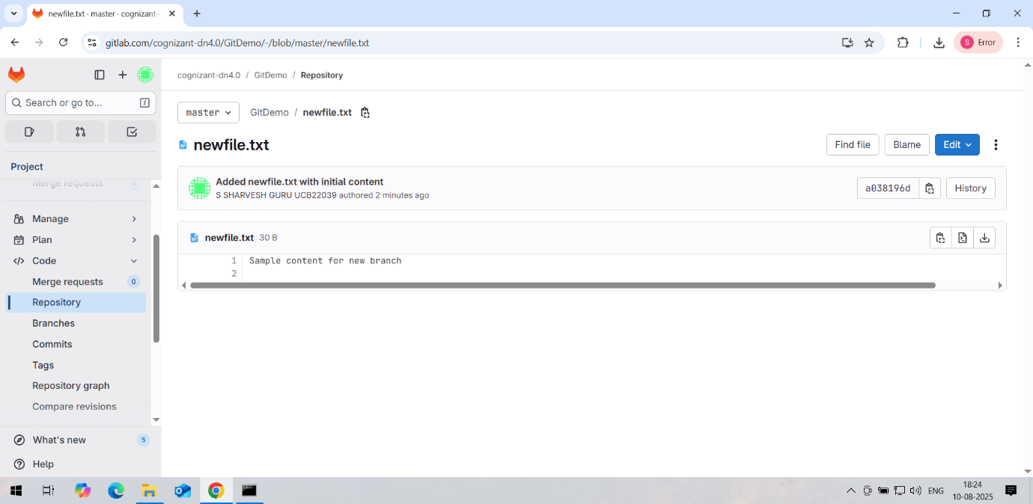

**4. Git-HOL**

user@DESKTOP-TB29U4O MINGW64 ~/GitDemo (master)

$ git checkout master

Already on 'master'

user@DESKTOP-TB29U4O MINGW64 ~/GitDemo (master)

$ git status

On branch master

nothing to commit, working tree clean

user@DESKTOP-TB29U4O MINGW64 ~/GitDemo (master)

$ git checkout -b GitWork

Switched to a new branch 'GitWork'

user@DESKTOP-TB29U4O MINGW64 ~/GitDemo (GitWork)

$ echo "<message>Hello from GitWork</message>" > hello.xml

user@DESKTOP-TB29U4O MINGW64 ~/GitDemo (GitWork)

$ echo "<note>Updated content in GitWork branch</note>" >> hello.xml

user@DESKTOP-TB29U4O MINGW64 ~/GitDemo (GitWork)

$ git status

On branch GitWork

Untracked files:

(use "git add <file>..." to include in what will be committed)

hello.xml

nothing added to commit but untracked files present (use "git add" to track)

user@DESKTOP-TB29U4O MINGW64 ~/GitDemo (GitWork)

$ git add hello.xml

warning: in the working copy of 'hello.xml', LF will be replaced by CRLF the next time Git touches it

user@DESKTOP-TB29U4O MINGW64 ~/GitDemo (GitWork)

$ git commit -m "Added and updated hello.xml in GitWork"

[GitWork d9becbe] Added and updated hello.xml in GitWork

1 file changed, 2 insertions(+)

create mode 100644 hello.xml

user@DESKTOP-TB29U4O MINGW64 ~/GitDemo (GitWork)

$ git checkout master

Switched to branch 'master'

user@DESKTOP-TB29U4O MINGW64 ~/GitDemo (master)

$ echo "<message>Hello from Master</message>" > hello.xml

user@DESKTOP-TB29U4O MINGW64 ~/GitDemo (master)

$ git add hello.xml

warning: in the working copy of 'hello.xml', LF will be replaced by CRLF the next time Git touches it

user@DESKTOP-TB29U4O MINGW64 ~/GitDemo (master)

$ git commit -m "Added hello.xml in master with different content"

[master a5066cd] Added hello.xml in master with different content

1 file changed, 1 insertion(+)

create mode 100644 hello.xml

user@DESKTOP-TB29U4O MINGW64 ~/GitDemo (master)

$ git log --oneline --graph --decorate --all

* a5066cd (HEAD -> master) Added hello.xml in master with different content

| * d9becbe (GitWork) Added and updated hello.xml in GitWork

|/

* a038196 (origin/master) Added newfile.txt with initial content

* 50222fc Add gitignore

* 4c0e3a8 add welcome.txt

user@DESKTOP-TB29U4O MINGW64 ~/GitDemo (master)

$ git diff GitWork

diff --git a/hello.xml b/hello.xml

index e80e075..3fa01db 100644

--- a/hello.xml

+++ b/hello.xml

@@ -1,2 +1 @@

-<message>Hello from GitWork</message>

-<note>Updated content in GitWork branch</note>

+<message>Hello from Master</message>

user@DESKTOP-TB29U4O MINGW64 ~/GitDemo (master)

$ git merge GitWork

Auto-merging hello.xml

CONFLICT (add/add): Merge conflict in hello.xml

Automatic merge failed; fix conflicts and then commit the result.

$ git log --oneline --graph --decorate --all

* a5066cd (HEAD -> master) Added hello.xml in master with different content

| * d9becbe (GitWork) Added and updated hello.xml in GitWork

|/

* a038196 (origin/master) Added newfile.txt with initial content

* 50222fc Add gitignore

* 4c0e3a8 add welcome.txt

user@DESKTOP-TB29U4O MINGW64 ~/GitDemo (master|MERGING)

$ git config --global diff.tool p4merge

user@DESKTOP-TB29U4O MINGW64 ~/GitDemo (master|MERGING)

$ git difftool master GitWork

user@DESKTOP-TB29U4O MINGW64 ~/GitDemo (master|MERGING)

$ git merge GitWork

error: Merging is not possible because you have unmerged files.

hint: Fix them up in the work tree, and then use 'git add/rm <file>'

hint: as appropriate to mark resolution and make a commit.

fatal: Exiting because of an unresolved conflict.

user@DESKTOP-TB29U4O MINGW64 ~/GitDemo (master|MERGING)

$ git config --global merge.tool p4merge

user@DESKTOP-TB29U4O MINGW64 ~/GitDemo (master|MERGING)

$ git config --global merge.conflictstyle diff3

user@DESKTOP-TB29U4O MINGW64 ~/GitDemo (master|MERGING)

$ git mergetool

Merging:

hello.xml

Normal merge conflict for 'hello.xml':

{local}: created file

{remote}: created file

error: invalid path './hello_BASE_869.xml'

user@DESKTOP-TB29U4O MINGW64 ~/GitDemo (master|MERGING)

$ git mergetool

No files need merging

user@DESKTOP-TB29U4O MINGW64 ~/GitDemo (master|MERGING)

$ git merge GitWork

fatal: You have not concluded your merge (MERGE_HEAD exists).

Please, commit your changes before you merge.

user@DESKTOP-TB29U4O MINGW64 ~/GitDemo (master|MERGING)

$ git commit -m "Merged GitWork into master and resolved conflict in hello.xml"

[master a9c9fed] Merged GitWork into master and resolved conflict in hello.xml

user@DESKTOP-TB29U4O MINGW64 ~/GitDemo (master)

$ git status

On branch master

Untracked files:

(use "git add <file>..." to include in what will be committed)

hello.xml.orig

hello_BACKUP_2333.xml

hello_BACKUP_2412.xml

hello_BACKUP_2496.xml

hello_BASE_2333.xml

hello_BASE_2412.xml

hello_BASE_2496.xml

hello_LOCAL_2333.xml

hello_LOCAL_2412.xml

hello_LOCAL_2496.xml

hello_REMOTE_2333.xml

hello_REMOTE_2412.xml

hello_REMOTE_2496.xml

nothing added to commit but untracked files present (use "git add" to track)

user@DESKTOP-TB29U4O MINGW64 ~/GitDemo (master)

$ echo "*.bak" >> .gitignore

user@DESKTOP-TB29U4O MINGW64 ~/GitDemo (master)

$ git add .gitignore

warning: in the working copy of '.gitignore', LF will be replaced by CRLF the next time Git touches it

user@DESKTOP-TB29U4O MINGW64 ~/GitDemo (master)

$ git commit -m "Added .bak files to .gitignore"

[master ae433e7] Added .bak files to .gitignore

1 file changed, 1 insertion(+)

user@DESKTOP-TB29U4O MINGW64 ~/GitDemo (master)

$ git branch

GitWork

* master

user@DESKTOP-TB29U4O MINGW64 ~/GitDemo (master)

$ git branch -d GitWork

Deleted branch GitWork (was d9becbe).

user@DESKTOP-TB29U4O MINGW64 ~/GitDemo (master)

$ git log --oneline --graph --decorate

* ae433e7 (HEAD -> master) Added .bak files to .gitignore

* a9c9fed Merged GitWork into master and resolved conflict in hello.xml

|\

| * d9becbe Added and updated hello.xml in GitWork

* | a5066cd Added hello.xml in master with different content

|/

* a038196 (origin/master) Added newfile.txt with initial content

* 50222fc Add gitignore

* 4c0e3a8 add welcome.txt

user@DESKTOP-TB29U4O MINGW64 ~/GitDemo (master)

$ git push origin master

warning: redirecting to https://gitlab.com/cognizant-dn4.0/GitDemo.git/

Enumerating objects: 12, done.

Counting objects: 100% (12/12), done.

Delta compression using up to 3 threads

Compressing objects: 100% (8/8), done.

Writing objects: 100% (10/10), 1.17 KiB | 239.00 KiB/s, done.

Total 10 (delta 2), reused 0 (delta 0), pack-reused 0 (from 0)

remote:

remote: To create a merge request for master, visit:

remote: https://gitlab.com/cognizant-dn4.0/GitDemo/-/merge_requests/new?merge_request%5Bsource_branch%5D=master

remote:

To https://gitlab.com/cognizant-dn4.0/GitDemo

a038196..ae433e7 master -> master

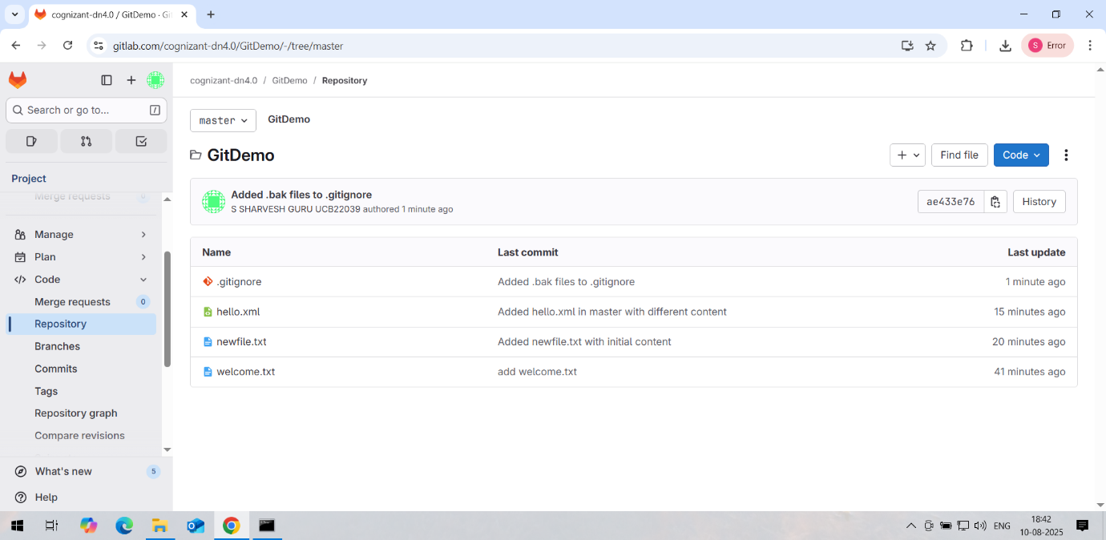

**5. Git-HOL**

user@DESKTOP-TB29U4O MINGW64 ~/GitDemo (master)

$ git checkout master

Already on 'master'

user@DESKTOP-TB29U4O MINGW64 ~/GitDemo (master)

$ git status

On branch master

Untracked files:

(use "git add <file>..." to include in what will be committed)

hello.xml.orig

hello_BACKUP_2333.xml

hello_BACKUP_2412.xml

hello_BACKUP_2496.xml

hello_BASE_2333.xml

hello_BASE_2412.xml

hello_BASE_2496.xml

hello_LOCAL_2333.xml

hello_LOCAL_2412.xml

hello_LOCAL_2496.xml

hello_REMOTE_2333.xml

hello_REMOTE_2412.xml

hello_REMOTE_2496.xml

nothing added to commit but untracked files present (use "git add" to track)

user@DESKTOP-TB29U4O MINGW64 ~/GitDemo (master)

$ git branch # Local branches

* master

user@DESKTOP-TB29U4O MINGW64 ~/GitDemo (master)

$ git branch -r # Remote branches

origin/master

user@DESKTOP-TB29U4O MINGW64 ~/GitDemo (master)

$ git checkout master

Already on 'master'

user@DESKTOP-TB29U4O MINGW64 ~/GitDemo (master)

$ git pull origin master

warning: redirecting to https://gitlab.com/cognizant-dn4.0/GitDemo.git/

From https://gitlab.com/cognizant-dn4.0/GitDemo

* branch master -> FETCH_HEAD

Already up to date.

user@DESKTOP-TB29U4O MINGW64 ~/GitDemo (master)

$ git checkout Git-T03-HOL_002

error: pathspec 'Git-T03-HOL_002' did not match any file(s) known to git

user@DESKTOP-TB29U4O MINGW64 ~/GitDemo (master)

$ git fetch origin

warning: redirecting to https://gitlab.com/cognizant-dn4.0/GitDemo.git/

remote: Enumerating objects: 3, done.

remote: Counting objects: 100% (3/3), done.

remote: Compressing objects: 100% (2/2), done.

remote: Total 3 (delta 0), reused 0 (delta 0), pack-reused 0 (from 0)

Unpacking objects: 100% (3/3), 2.75 KiB | 148.00 KiB/s, done.

From https://gitlab.com/cognizant-dn4.0/GitDemo

* [new branch] main -> origin/main

user@DESKTOP-TB29U4O MINGW64 ~/GitDemo (master)

$ git log origin/Git-T03-HOL_002

fatal: ambiguous argument 'origin/Git-T03-HOL_002': unknown revision or path not in the working tree.

Use '--' to separate paths from revisions, like this:

'git <command> [<revision>...] -- [<file>...]'